python main_dqn.py -n_epochs=1_000

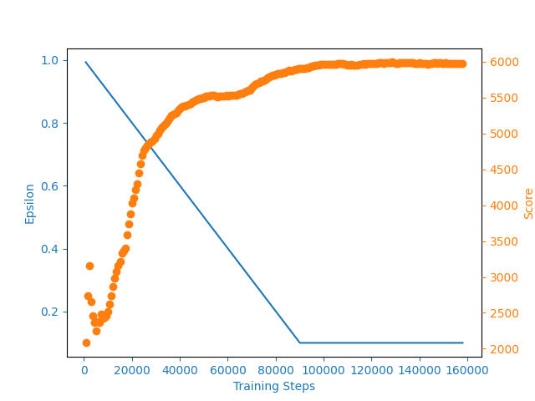
episode: 487 score: 5950.0 average score 5918.6 best score 5974.23 epsilon 0.1000 steps 348911

